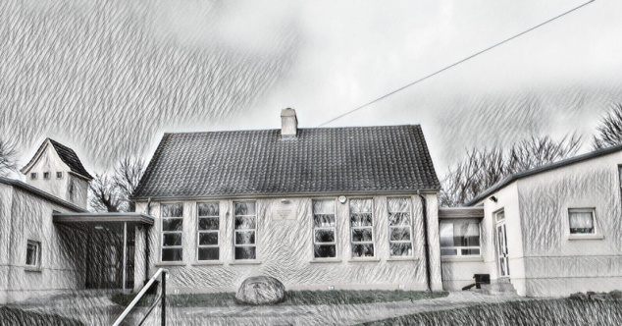 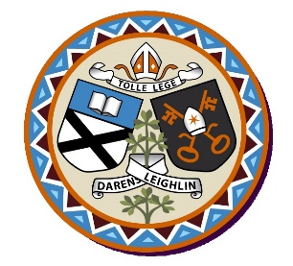 **Rathmore NS**

**Annual Admission Notice**

in respect of admissions to the 2025/2026 school year

**Admission Policy and Application Form**

A copy of the school’s **Admission Policy** and the **Application Form for Admission** for the 2025-2026 is available as follows: –

To download at: <https://rathmorens.webador.ie/>

On request: By emailing [rathmorens.ias@gmail.com](mailto:rathmorens.ias@gmail.com) or writing to Rathmore NS, Rathmore, Tullow, Co Carlow, R93 YH51

**Part 1 - Admissions to the** 2025-2026 **school year**

**Application and Decision Dates for admission to** *Rathmore Ns 2025-2026*

The following are the dates applicable for admission to Junior Infants

|  |  |
| --- | --- |
| The school will commence accepting applications for admission on | 25/10/2024 |
| The school shall cease accepting applications for admission on | 15/11/2024 |
| The date by which applicants will be notified of the decision on their application is | 29/11/2024 |
| The period within which applicants must confirm acceptance of an offer of admission is | 13/12/2024 |

**Note: The school will consider and issue decisions on late applications in accordance** with the school’s Admission Policy.

***\*Failure to accept an offer within the prescribed period above may result in the offer being withdrawn***

**Number of Places being made Available in** 2025-2026

|  |  |
| --- | --- |
| The number of places being made available in junior infants | **8** |